Faculty Orientation Workshop at IMI-Kolkata (Under IQAC) on 03.06.2024
On 3rd June 2024, a Faculty Orientation workshop was conducted at IMI Kolkata under IQAC to provide an overall objective of IMI Kolkata’s Vision and Mission through the overview of the PGDM program, research ecosystem and other allied activities at IMI-Kolkata.
Prof. Rachana Chattaopdhatyay, Dean Academics, delves into the PGDM program by discussing various aspects one by one such as Programme Competencies and Learning Objectives, Programme Structure: Course credits guidelines by AICTE, Systematic process of Curriculum Design and Development. She also appraised the newly joined faculty members regarding Outcome Based Learning (OBE) through the OBE model. Differences between the objectives and outcomes. Prof. Chattopadhyaya proceeded into the detailed process of developing Course Outcomes or Course Learning Outcomes (CO/CLO) through Bloom’s Taxonomy action verbs and activities. Moreover, faculty members were also appraised of the Assessment of Learning method and rubrics allied to the method.
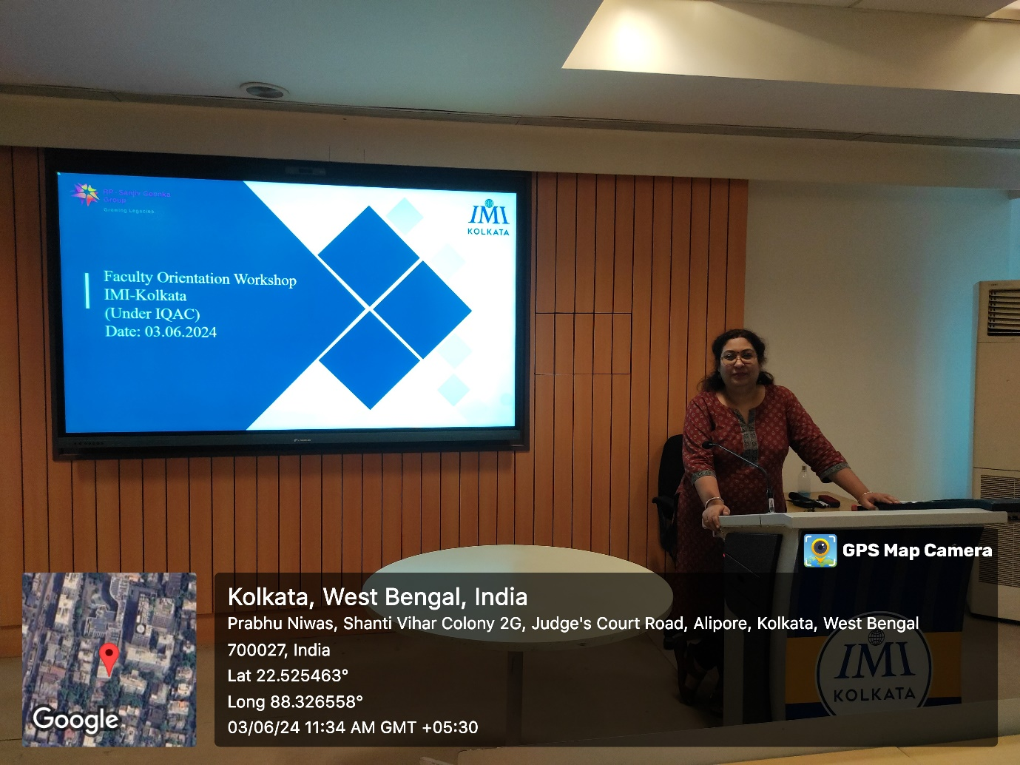

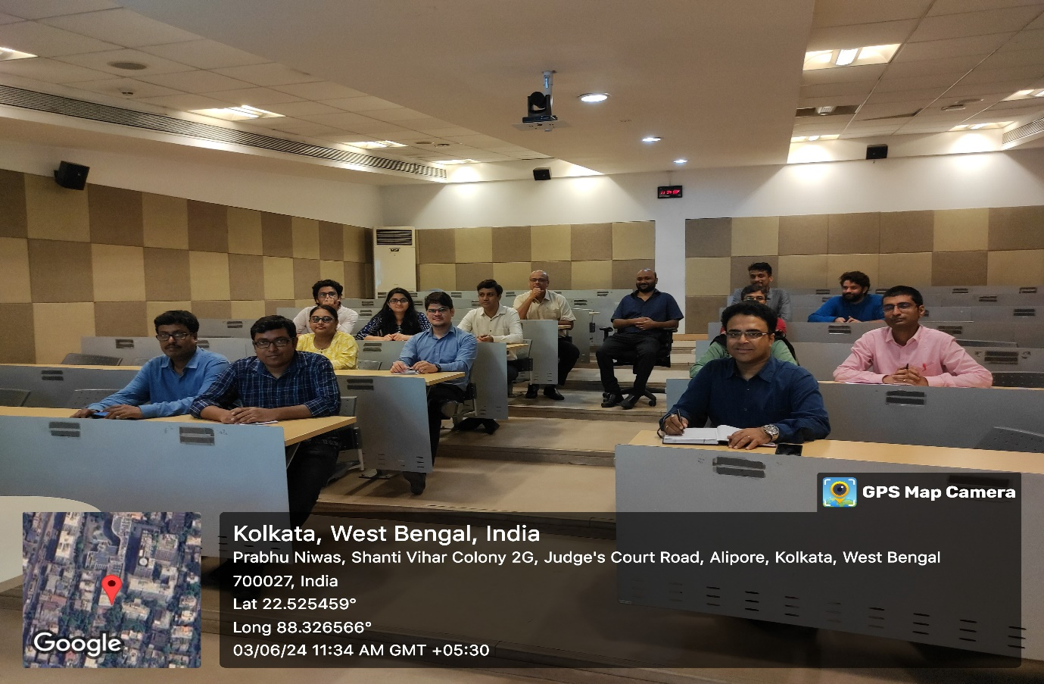
Prof. Tirthanlkar Nag, Dean of Research and International Collaboration addressed the research ecosystem of IMI Kolkata. Prof. Nag appraised faculty members of the benchmarks like ABDC, SCOPUS, WoS, ABS and so that have been set to produce high-quality research. An attempt was also made to align the benchmark with research incentives of other Business Schools. He also discussed the significance of producing quality research that has been synced with the reduction of course load, promotion eligibility criteria and opportunities to receive international paper presentation travel grants provided by IMI Kolkata.

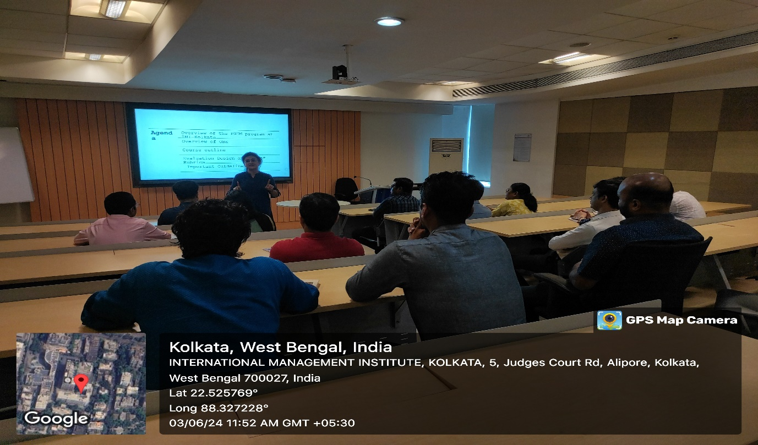
Prof. Mohua Banerjee, Director, IMI Kolkata ended the orientation workshop by addressing the faculty members regarding the overall activities, roles and responsibilities while focusing on the holistic developments of faculties at IMI Kolkata.

